II - ASSIGNMENT

1. Using input () function take one number from the user and using ternary operators check whether the number is even or odd.

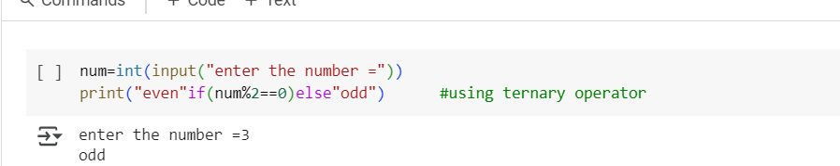

Output

Enter the number =3

Odd

1. Using input function take two number and then swap the number.

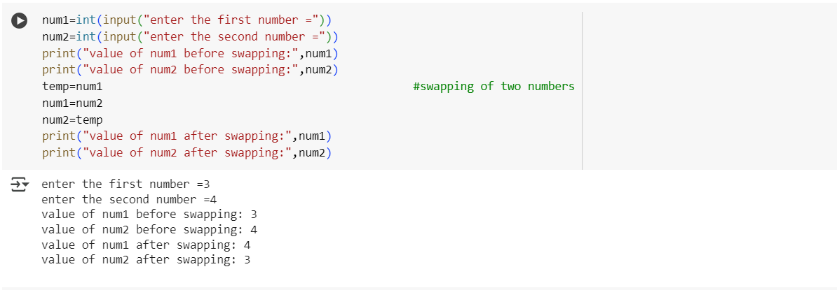

Output

Enter the first number=3

Enter the second number =4

Value of num1 before swapping:3

Value of num2 before swapping:4

Value of num1 after swapping:4

Value of num2 after swapping:3

1. Write a program to convert Kilometers to Miles.

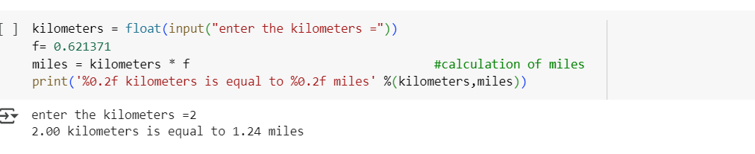

Output

Enter the kilometers =2

2.00 kilometers is equal to 1.24 miles

1. Find the simple interest on Rs.200 for 5 years at 5% per year.

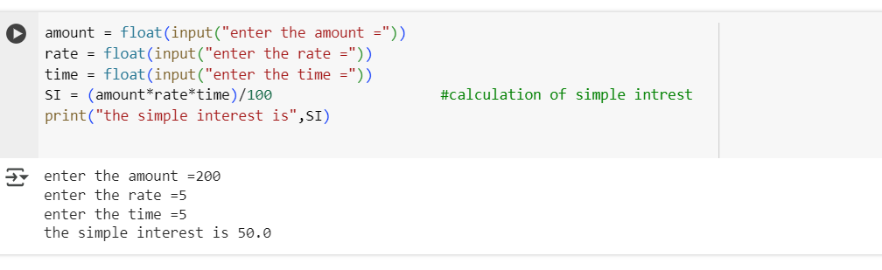

Output

Enter the amount =200

Enter the rate =5

Enter the time =5

The simple interest is 50.0